21BCE6061
Darshan J Patel

Os Lab – 2
1 st code add 3 number
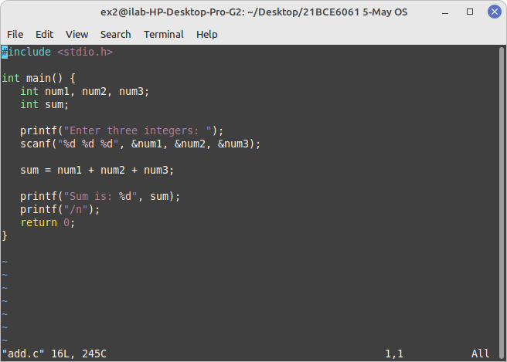
Output :
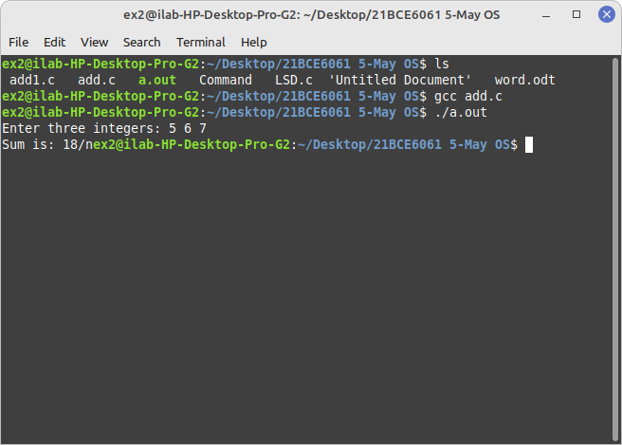
2nd Questiion Least Domination
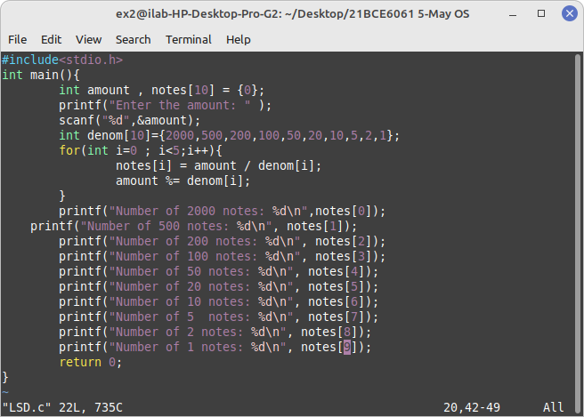
Output :
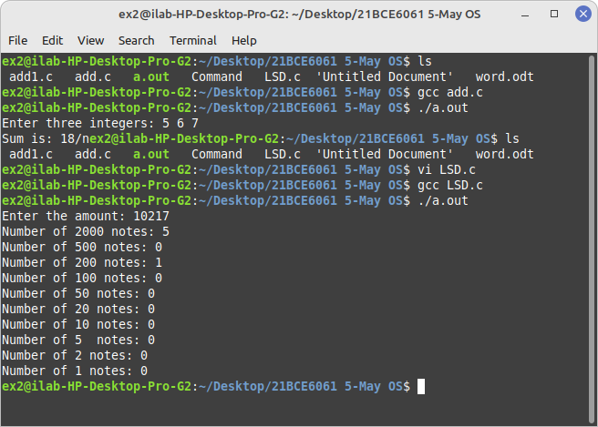
3rd

write a number k write a c program to find the number of 0;s in k
Input : 5000
Output : 3 0’s are there
Code :
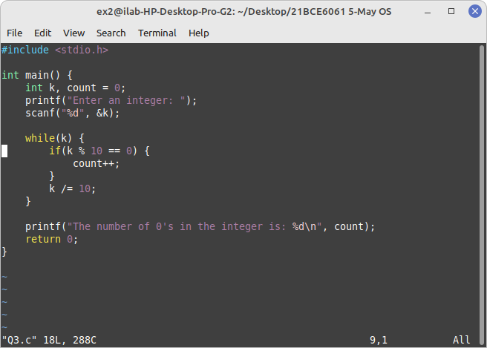
Output

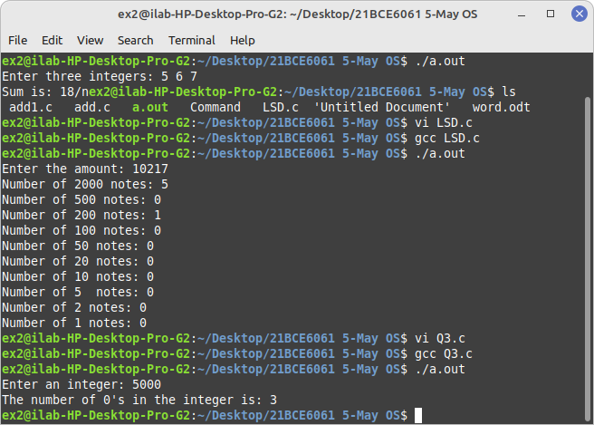
Q-4 given a number k and digit t , check if t occurs in k and display the of times of occur in k.

Code :
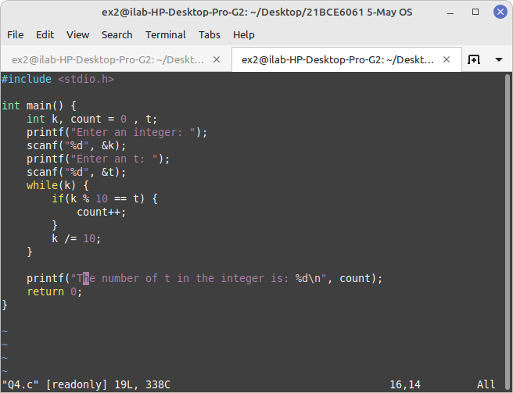
Ouptut :

